WEEK 5 MICROSERVICES
SUKHPREET JENA
SUPERSET ID : 6399056
Creating Microservices for account and loan
ACCOUNT MICROSERVICES
AccountApplication.java
package com.example.account;
import org.springframework.boot.SpringApplication;
import org.springframework.boot.autoconfigure.SpringBootApplication;
@SpringBootApplication
public class AccountApplication {
public static void main(String[] args) {
SpringApplication.run(AccountApplication.class, args);
}
}
AccountController.java
package com.example.account.controller;
import org.springframework.web.bind.annotation.*;
import java.util.Map;
@RestController
@RequestMapping("/accounts")
public class AccountController {
@GetMapping("/{number}")
public Map<String, Object> getAccountDetails(@PathVariable String number) {
return Map.of(
"number", number,
"type", "savings",
"balance", 234343
);}}
AccountApplicationTests.java
package com.example.account;
import org.junit.jupiter.api.Test;
import org.springframework.boot.test.context.SpringBootTest;
@SpringBootTest
class AccountApplicationTests {
@Test
void contextLoads() {
}
}

OUTPUT
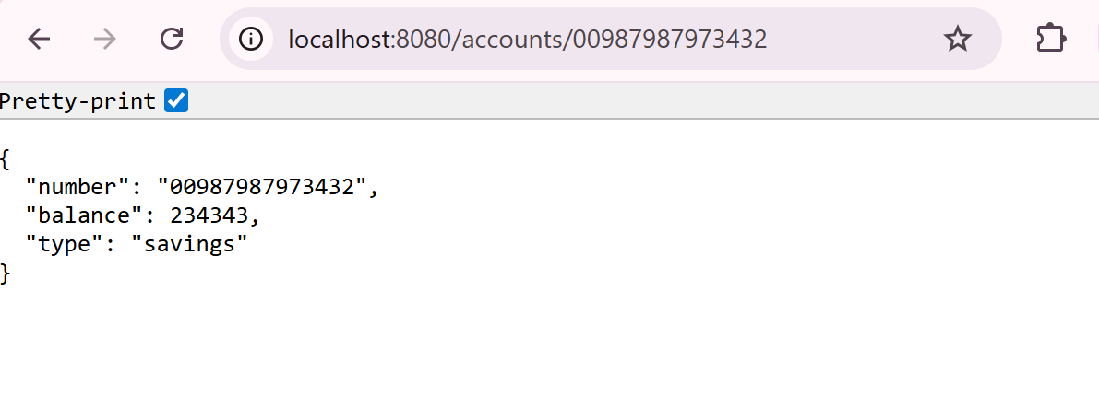

LOAN MICROSERVICES
LoanApplication.java
package com.example.loan;
import org.springframework.boot.SpringApplication;
import org.springframework.boot.autoconfigure.SpringBootApplication;
@SpringBootApplication
public class LoanApplication {
public static void main(String[] args) {
SpringApplication.run(LoanApplication.class, args);
}
}
LoanController.java
package com.example.loan.controller;
import org.springframework.web.bind.annotation.*;
@RestController
@RequestMapping("/loans")
public class LoanController {
@GetMapping("/{number}")
public Loan getLoanByNumber(@PathVariable String number) {
return new Loan("H00987987972342", "car", 400000, 3258, 18);
}
static class Loan {
public String number;
public String type;
public int loan;
public int emi;
public int tenure;
public Loan(String number, String type, int loan, int emi, int tenure) {
this.number = number;
this.type = type;
this.loan = loan;
this.emi = emi;
this.tenure = tenure;
}
}
}

OUTPUT

